- UNIT :- 1

- Contaminants in the Environm

Oil impacts to the beach environment of Grand Isle, Louisiana. Oil and other chemicals can get into sediments, impacting large coastal areas, threatening human health, and reducing the economic well being of regions that depend on a healthy coastal environment.
Our ocean and coastal areas provide us with a lot – from food, places to boat and swim, and wildlife to enjoy…the list goes on. So when these areas become polluted and unhealthy, it isn’t just bad for the environment, it’s also bad for us. At NOS, scientists, economists, and other experts are busy monitoring, assessing, and working to clean up contaminants in the environment.
- The source
A wide range of chemicals can contaminate our water, land, or air, impacting the environment and our health. Most contaminants enter the environment from industrial and commercial facilities; oil and chemical spills; non-point sources such as roads, parking lots, and storm drains; and wastewater treatment plants and sewage systems. Many hazardous waste sites and industrial facilities have been contaminated for decades and continue to affect the environment.
- The impact
Contaminants in the environment can look and smell pretty nasty, but their impacts go beyond just aesthetics. Some pollutants resist breakdown and accumulate in the food chain. These pollutants can be consumed or absorbed by fish and wildlife, which in turn may be eaten by us. Chemicals can also get into sediments, impacting large coastal areas, threatening human health, and reducing the economic well being of regions that depend on a healthy coastal environment.

- Evaluation tools
Being able to clean up and restore areas that have been impacted by contaminants requires tools tailored to the needs of specific regions. NOS has developed a range of tools to help coastal communities meet their needs. For example, following the Deepwater Horizon oil spill incident in the Gulf of Mexico, NOAA worked with partners to launch the Environmental Response Management Application (ERMA®) Gulf Response, an online mapping tool that delivers environmental resource managers the near-real-time information and data necessary to make informed decisions for environmental response. The site uses the Environmental Response Management Application, a web-based geographic information system platform developed by NOAA and the University of New Hampshire’s Coastal Response Research Center. NOS also offers a number of assessment tools and guidance to help coastal decision makers understand the implications of contaminated sediments.

- Testing toxicity
Harmful chemical pollution and excess nutrient runoff are serious threats to the coastal environment. NOS scientists are conducting research to help detect and predict how this pollution will impact coastal resources. For example, at the National Centers for Coastal Ocean Science, scientists are evaluating the effects of single contaminants and contaminant mixtures, conducting toxicity-testing with single species, and conducting research in controlled conditions to assess contaminant impacts on biological communities. Scientists are also looking at how environmental and human stressors impact bottlenose dolphin populations.

- Responding to contaminants
When contaminants threaten or harm aquatic species, make them unsafe to eat, or degrade their habitat, NOS experts work with partners to evaluate risks and injuries, develop strategies to reduce contaminant loads, and reduce the risk to species. The experts also monitor the effectiveness of cleanup actions and design and implement projects to restore natural resources. At larger waste sites and after oil spills, NOS scientists and economists conduct natural resource damage assessments to determine the nature and extent of harm to natural resources and restoration necessary to bring the resources to a healthier state. NOS works with the parties responsible for the contamination to ensure that injured coastal and marine resources are restored.

- Nonpoint pollution
When pollution comes from a source that can't be tied to a specific location, we call it “nonpoint source pollution.” This kind of pollution occurs when leaking septic tanks or stormwater runoff that has picked up things like sediment, fertilizer, pet waste, or oil drain into streams and rivers that empty into our estuaries and coastal waters. To address this polluted runoff, NOAA and the Environmental Protection Agency jointly administer the Coastal Nonpoint Pollution Control Program. Under the program, all states and territories with approved coastal zone management programs are required to develop and implement coastal programs to reduce the amount of nonpoint source pollution entering our waterways.
- Definition of Air Pollution
Air pollution is the presence of harmful substances in the atmosphere that are detrimental to human health, the environment, and living organisms. These substances can be gases, particulates, or biological molecules that cause harm or discomfort.
- Impact of SOx (Sulfur Oxides) on Human Beings
- Respiratory Problems: SOx gases, mainly sulfur dioxide (SO2), irritate the respiratory tract, causing coughing, shortness of breath, and aggravation of asthma and bronchitis.
- Eye Irritation: Exposure to SO2 can cause eye irritation and discomfort.
- Long-term Effects: Prolonged exposure can lead to chronic respiratory diseases and reduced lung function.
- Other Effects: SOx contributes to the formation of acid rain, which indirectly affects human health by contaminating water and food sources.
- Impact of NOx (Nitrogen Oxides) on Human Beings
- Respiratory Issues: NOx gases, especially nitrogen dioxide (NO2), irritate the airways, leading to coughing, wheezing, and increased susceptibility to respiratory infections.
- Aggravation of Lung Diseases: NOx exposure worsens conditions like asthma and chronic obstructive pulmonary disease (COPD).
- Reduced Lung Function: Long-term exposure can decrease lung function and increase the risk of respiratory diseases.
- Formation of Smog and Acid Rain: NOx contributes to photochemical smog and acid rain, which have indirect harmful effects on human health.
Both SOx and NOx are significant air pollutants that pose serious health risks, especially to vulnerable populations such as children, the elderly, and those with pre-existing respiratory conditions.

- Photochemical smog
Photochemical smog, often called "Los Angeles smog," is a type of air pollution primarily affecting urban areas with heavy automobile traffic. It forms when nitrogen oxides and hydrocarbon vapors, released by vehicles and other sources, react in the lower atmosphere under sunlight. A key component of this smog is ozone, a toxic gas that irritates the eyes and respiratory system, reduces visibility, and can damage plants. Factors like mountains and temperature inversions can trap these pollutants, worsening smog conditions. Unlike sulfurous smog, photochemical smog does not require smoke or fog to form.
- Indoor air pollution
Indoor air pollution (IAP) is a serious threat to human health, causing millions of deaths each year. A plethora of pollutants can result in IAP; therefore, it is very important to identify their main sources and concentrations and to devise strategies for the control and enhancement of indoor air quality (IAQ). Herein, we provide a critical review and evaluation of the major sources of major pollutant emissions, their health effects, and issues related to IAP-based illnesses, including sick building syndrome (SBS) and building-related illness (BRI). In addition, the strategies and approaches for control and reduction of pollutant concentrations are pointed out, and the recent trends in efforts to resolve and improve IAQ, with their respective advantages and potentials, are summarized. It is predicted that the development of novel materials for sensors, IAQ-monitoring systems, and smart homes is a promising strategy for control and enhancement of IAQ in the future.
Keywords: indoor air quality, indoor pollution, smart home, human diseases

1. Introduction
Indoor environment conditions contribute greatly to human wellbeing, as most people spend around 90% of their time indoors, mainly at home or in the workplace [1]. According to the World Health Organization (WHO), indoor air pollution (IAP) is responsible for the deaths of 3.8 million people annually [2]. IAP can be generated inside homes or buildings through occupants’ activities, such as cooking, smoking, use of electronic machines, use of consumer products, or emission from building materials. Harmful pollutants inside buildings include carbon monoxide (CO), volatile organic compounds (VOCs), particulate matter (PM), aerosol, biological pollutants, and others [3]. Therefore, over the past decade, research on air quality control has begun to shift from outdoor to indoor environments, as reflects lifestyle changes linked to increased levels of urbanization [4]. It was indicated that decreased IAQ can negatively affect human health by causing building-associated illness [5]. Both short- and long-term IAP exposure can cause a wide range of diseases [6]. Therefore, the development of monitoring systems has a vital role to play in IAQ control.
IAP normally is a complex mixture of particulate and various gaseous components. IAP compositions differ significantly depending on sources, emission rates, and ventilation conditions [7]. For effective control of IAQ, therefore, it is necessary to determine the sources of air pollution. Moreover, the development of monitoring systems for the measurement of indoor pollutant concentrations as well as key strategies for control and enhancement of IAQ are considered essential. In this paper, we provide a comprehensive overview of the major IAP sources and IAQ-control strategies; we emphasize the sources, characteristics, and health effects of each IAP; we identify and discuss health issues and building-associated illnesses related to an IAQ decrease; and finally, we present the recent and trending strategies for the control and reduction of pollutant concentrations and better IAQ. It is expected that promising strategies for monitoring and control of IAQ in the future will include novel materials-based sensors, smart monitoring systems, and smart homes.

Carbon Cycle (Gaseous Cycle)

- Carbon is a minor constituent of the atmosphere as compared to oxygen and nitrogen.
- However, without carbon dioxide life could not exist because it is vital for the production of carbohydrates through photosynthesis by plants.
- It is the element that anchors all organic substances from coal and oil to DNA (deoxyribonucleic acid: the compound that carries genetic information).
- Carbon is present in the atmosphere, mainly in the form of carbon dioxide (CO₂).
- Carbon cycle involves a continuous exchange of carbon between the atmosphere and organisms.
- Carbon from the atmosphere moves to green plants by the process of photosynthesis, and then to animals.
- By process of respiration and decomposition of dead organic matter, it returns to the atmosphere. It is usually a short term cycle.
- Some carbon also enters a long term cycle. It accumulates as un-decomposed organic matter in the peaty layers of marshy soil or as insoluble carbonates in bottom sediments of aquatic systems which take a long time to be released.
- In deep oceans, such carbon can remain buried for millions of years till geological movement may lift these rocks above sea level.
- These rocks may be exposed to erosion, releasing their carbon dioxide, carbonates and bicarbonates into streams and rivers.
- Fossil fuels such as coals, oil and natural gas etc. are organic compounds that were buried before they could be decomposed and were subsequently transformed by time and geological processes into fossil fuels. When they are burned the carbon stored in them is released back into the atmosphere as carbon dioxide.

Nitrogen Cycle (Gaseous Cycle)

- Apart from carbon, hydrogen and oxygen, nitrogen is the most prevalent element in living organisms.
- Nitrogen is a constituent of amino acids, proteins, hormones, chlorophylls and many of the vitamins (explained in Biology NCERT).
- Plants compete with microbes for the limited nitrogen that is available in the soil. Thus, nitrogen is a limiting nutrient for both natural and agricultural ecosystems.
- Nitrogen exists as two nitrogen atoms (N2) joined by a very strong triple covalent bond (N ≡ N).
- In nature, lightning and ultraviolet radiation provide enough energy to convert nitrogen to nitrogen oxides (NO, NO2, N2O).
- Industrial combustions, forest fires, automobile exhausts and power-generating stations are also sources of atmospheric nitrogen oxides.

- Nitrogen Fixing – Nitrogen to Ammonia (N2 to NH3)
- There is an inexhaustible supply of nitrogen in the atmosphere, but the elemental form cannot be used directly by most of the living organisms.
- Nitrogen needs to be ‘fixed’, that is, converted to ammonia, nitrites or nitrates, before it can be taken up by plants.
- Nitrogen fixation on earth is accomplished in three different ways:
- By microorganisms (bacteria and blue-green algae),
- By man using industrial processes (fertiliser factories) and
- To a limited extent by atmospheric phenomena such as thunder and lighting.
- Certain microorganisms are capable of fixing atmospheric nitrogen into ammonia (NH3) and ammonium ions (NH4+).
- Ammonia (NH3) is a molecule consisting of nitrogen and hydrogen, while ammonium (NH4+) is an ion of ammonia that is formed by accepting a hydrogen ion.
- The enzyme, nitrogenase which is capable of nitrogen reduction is present exclusively in prokaryotes. Such microbes are called N2-fixers. These include:

Sulphur Cycle (Sedimentary cycle)

- The sulphur reservoir is in the soil and sediments where it is locked in organic (coal, oil and peat) and inorganic deposits (pyrite rock and sulphur rock) in the form of sulphates, sulphides and organic sulphur.
- It is released by weathering of rocks, erosional runoff and decomposition of organic matter and is carried to terrestrial and aquatic ecosystems in salt solution.
- The sulphur cycle is mostly sedimentary except two of its compounds, hydrogen sulphide (H₂S) and sulphur dioxide (SO₂), which add a gaseous component.
- Sulphur enters the atmosphere from several sources like volcanic eruptions, combustion of fossil fuels (coal, diesel etc.), from the surface of the ocean and gases released by decomposition.
- Atmospheric hydrogen sulphide also gets oxidised into sulphur dioxide.
- Atmospheric sulphur dioxide is carried back to the earth after being dissolved in rainwater as weak sulphuric acid (acid rain).
- Whatever the source, sulphur in the form of sulphates is taken up by plants and incorporated through a series of metabolic processes into sulphur bearing amino acid which is incorporated in the proteins of autotroph tissues. It then passes through the grazing food chain.
- Sulphur bound in a living organism is carried back to the soil, to the bottom of ponds and lakes and seas through excretion and decomposition of dead organic material.

What is Oxygen Cycle?
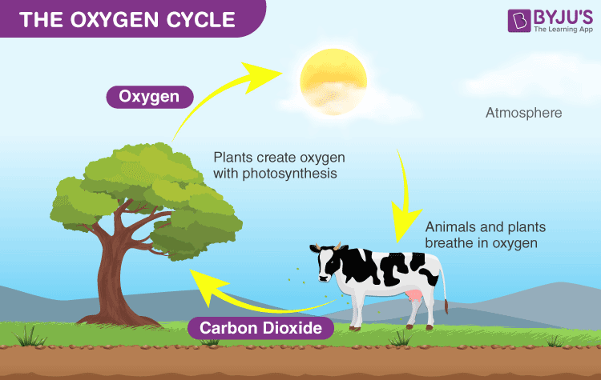
A Diagrammatic Representation of the Oxygen Cycle
Oxygen cycle, along with the carbon cycle and nitrogen cycle plays an essential role in the existence of life on the earth. The oxygen cycle is a biological process which helps in maintaining the oxygen level by moving through three main spheres of the earth which are:
- Atmosphere
- Lithosphere
- Biosphere
This biogeochemical cycle explains the movement of oxygen gas within the atmosphere, the ecosystem, biosphere and the lithosphere. The oxygen cycle is interconnected with the carbon cycle.
The atmosphere is the layer of gases presents above the earth’s surface. The sum of Earth’s ecosystems makes a biosphere. Lithosphere is the solid outer section along with the earth’s crust and it is the largest reservoir of oxygen.
Also Read: Biogeochemical Cycle

Stages of the Oxygen Cycle
The steps involved in the oxygen cycle are:
Stage-1: All green plants during the process of photosynthesis, release oxygen back into the atmosphere as a by-product.
Stage-2: All aerobic organisms use free oxygen for respiration.
Stage-3: Animals exhale Carbon dioxide back into the atmosphere which is again used by the plants during photosynthesis. Now oxygen is balanced within the atmospher
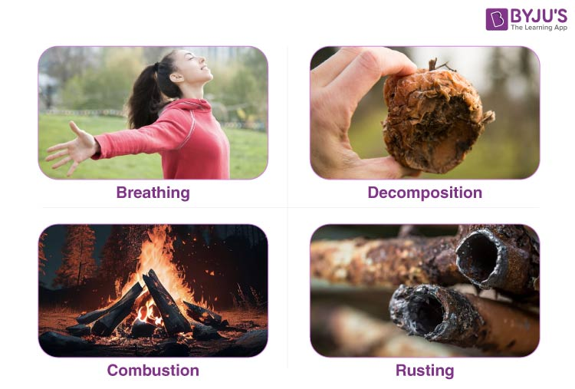
The four main processes that use atmospheric oxygen are:
Breathing – It is the physical process, through which all living organisms, including plants, animals and humans inhale oxygen from the outside environment into the cells of an organism and exhale carbon dioxide back into the atmosphere.
Decomposition: It is one of the natural and most important processes in the oxygen cycle and occurs when an organism dies. The dead animal or plants decay into the ground, and the organic matter along with the carbon, oxygen, water and other components are returned into the soil and air. This process is carried out by the invertebrates, including fungi, bacteria and some insects which are collectively called as the decomposers. The entire process requires oxygen and releases carbon dioxide.
Read more: Decomposition
Combustion: It is also one of the most important processes which occur when any of the organic materials, including fossil fuels, plastics and wood, are burned in the presence of oxygen and releases carbon dioxide into the atmosphere.
Rusting: This process also requires oxygen. It is the formation of oxides which is also called oxidation. In this process, metals like iron or alloy rust when they are exposed to moisture and oxygen for an extended period of time and new compounds of oxides are formed by the combination of oxygen with the metal.

Production of Oxygen
Plants: The leading creators of oxygen are plants by the process of photosynthesis. Photosynthesis is a biological process by which all green plants synthesize their food in the presence of sunlight. During photosynthesis, plants use sunlight, water, carbon dioxide to create energy and oxygen gas is liberated as a by-product of this process.
Sunlight: Sunlight also produces oxygen. Some oxygen gas is produced when the sunlight reacts with water vapour in the atmosphere.
Also Refer: Exchange Of Gases
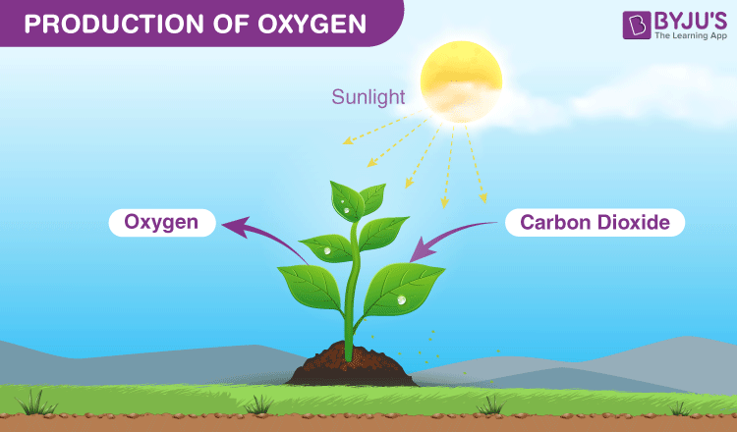

Some Interesting Facts about Oxygen
- Phytoplankton is one of the most significant producers of oxygen, followed by terrestrial plants and trees.
- Oxygen is also produced when the sunlight reacts with water vapour present in the atmosphere.
- A large amount of oxygen is stored in the earth’s crust in the form of oxides, which cannot be used for the respiration process as it is available in the combined state.

Importance of Oxygen Cycle
As we all know, oxygen is one of the most essential components of the earth’s atmosphere. It is mainly required for:
- Breathing
- Combustion
- Supporting aquatic life
- Decomposition of organic waste.
Oxygen is an important element required for life, however, it can be toxic to some anaerobic bacteria (especially obligate anaerobes).

